10.88: Assuming the blow to be concentrated at a point (or using a suitably chosen “average” point) at a distance from the hinge, 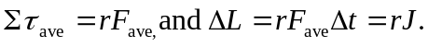
The angular velocity is then
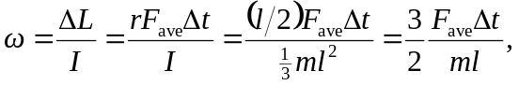
Where is the width of the door. Substitution of the given numeral values gives 